**Operation 1: Retrieving file names in ascending order**

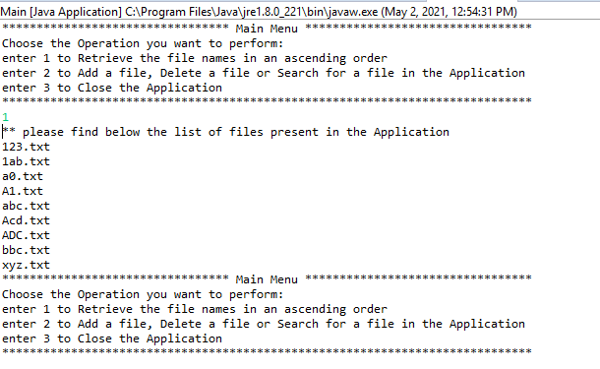

**Operation 2 : Business-level operations**

1. Add a file to the Application

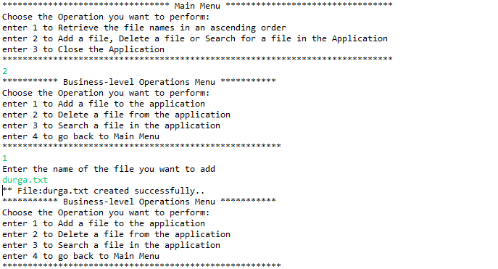

1. Delete a file from the Application

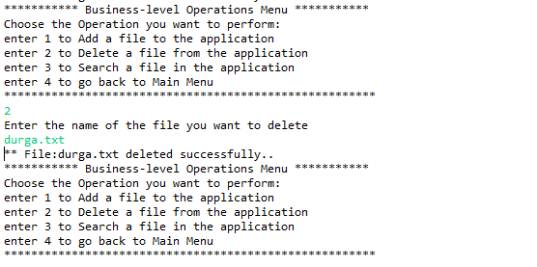

1. Search for a file

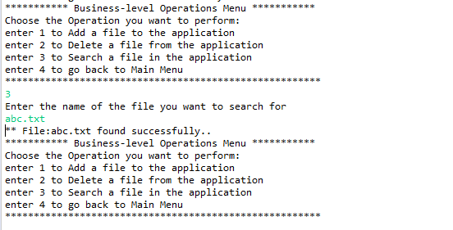

1. Navigate to Main Menu

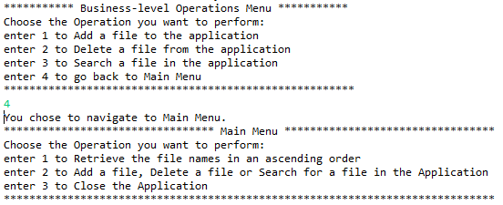

**Operation 3: Close the Application**

